**Assignment Report: Distributed System with Django, Threads, and Multiple Databases**

**Submitted By:**

**Name:** Pranali Kalokhe

## ****1. Objective****

The goal of this assignment was to create a Django project that simulates a distributed system by using **three separate SQLite databases** (users.db, products.db, and orders.db).  
The requirements were:

* Create tables manually.
* Insert at least 10 records into each table.
* Insert data **concurrently using threads**.
* Perform **all validations in Python**.
* Display the output after insertion and verify data using SQLite.

## ****2. Project Structure****

E:\distributed_system_assignment\

│

├── distributed_system\

│ ├── settings.py # Multiple database configuration

│

├── core\

│ ├── models.py # Models for Users, Products, Orders

│ ├── management\

│ │ └── commands\

│ │ ├── init_db.py # Create tables

│ │ └── insert_data.py # Insert data concurrently using threads

│

├── users.db # Users database

├── products.db # Products database

├── orders.db # Orders database

## ****3. Validation Rules****

Validations are applied in Python, not in the database:

| **Table** | **Validation Rules** |
| --- | --- |
| **Users** | Name must not be empty, Email must contain '@' |
| **Products** | Price must be greater than 0 |
| **Orders** | Quantity must be greater than 0, User & Product IDs must exist |
|  |  |

## ****4. Inserted vs. Skipped Records****

| **Table** | **Total Provided** | **Inserted** | **Skipped** | **Reason for Skipped Records** |
| --- | --- | --- | --- | --- |
| Users | 10 | 9 | 1 | User #10 → Empty name |
| Products | 10 | 9 | 1 | Product #10 → Negative price (-50) |
| Orders | 10 | 7 | 3 | Order #8 → Quantity 0 Order #9 → Quantity -1 Order #10 → Invalid product_id (11) |
|  |  |  |  |  |

## ****5. Execution Process****

### Step 1: Initialize Databases

Output:

users database initialized.

products database initialized.

orders database initialized.

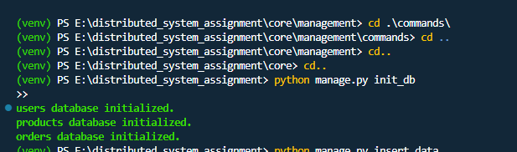

### Step 2: Insert Data Concurrently

python manage.py insert_data

=== INSERTED DATA ===

(venv) PS E:\distributed_system_assignment> python manage.py insert_data

>>

Output:

(venv) PS E:\distributed_system_assignment> python manage.py insert_data

>>

=== INSERTED DATA ===

ORDERS TABLE (Inserted):

(1, 1, 1, 2)

(2, 2, 2, 1)

(3, 3, 3, 5)

(4, 4, 4, 1)

(5, 5, 5, 3)

(6, 6, 6, 4)

(7, 7, 7, 2)

USERS TABLE (Inserted):

(1, 'Alice', 'alice@example.com')

(2, 'Bob', 'bob@example.com')

(3, 'Charlie', 'charlie@example.com')

(4, 'David', 'david@example.com')

(5, 'Eve', 'eve@example.com')

(6, 'Frank', 'frank@example.com')

(7, 'Grace', 'grace@example.com')

(8, 'Alice', 'alice@example.com')

(9, 'Henry', 'henry@example.com')

PRODUCTS TABLE (Inserted):

(1, 'Laptop', 1000.0)

(2, 'Smartphone', 700.0)

(3, 'Headphones', 150.0)

(4, 'Monitor', 300.0)

(5, 'Keyboard', 50.0)

(6, 'Mouse', 30.0)

(7, 'Laptop', 1000.0)

(8, 'Smartwatch', 250.0)

(9, 'Gaming Chair', 500.0)

ORDERS TABLE (Skipped):

(8, 8, 8, 0) --> Failed validation

(9, 9, 1, -1) --> Failed validation

(10, 10, 11, 2) --> Failed validation

USERS TABLE (Skipped):

(10, '', 'jane@example.com') --> Failed validation

PRODUCTS TABLE (Skipped):

(10, 'Earbuds', -50.0) --> Failed validation

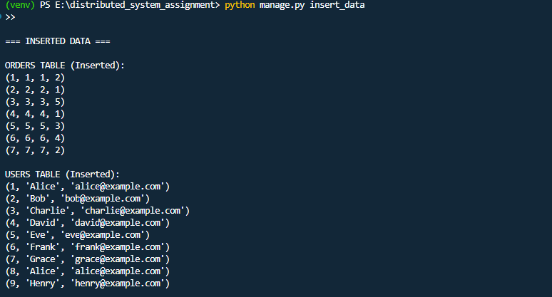

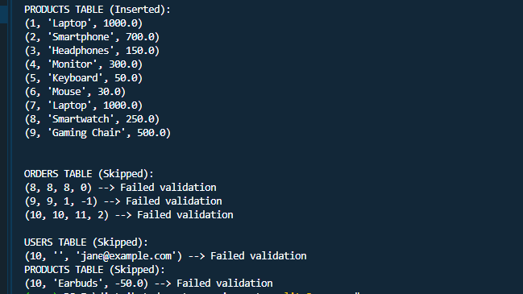

## ****6. Database Verification****

Verification using SQLite:

sqlite> .open E:\distributed_system_assignment\users.db

sqlite> SELECT * FROM users;

1|Alice|alice@example.com

2|Bob|bob@example.com

3|Charlie|charlie@example.com

4|David|david@example.com

5|Eve|eve@example.com

6|Frank|frank@example.com

7|Grace|grace@example.com

8|Alice|alice@example.com

9|Henry|henry@example.com

sqlite> .open E:\distributed_system_assignment\products.db

sqlite> SELECT * FROM products;

1|Laptop|1000.0

2|Smartphone|700.0

3|Headphones|150.0

4|Monitor|300.0

5|Keyboard|50.0

6|Mouse|30.0

7|Laptop|1000.0

8|Smartwatch|250.0

9|Gaming Chair|500.0

sqlite> .open E:\distributed_system_assignment\orders.db

sqlite> SELECT * FROM orders;

1|1|1|2

2|2|2|1

3|3|3|5

4|4|4|1

5|5|5|3

6|6|6|4

7|7|7|2

sqlite>

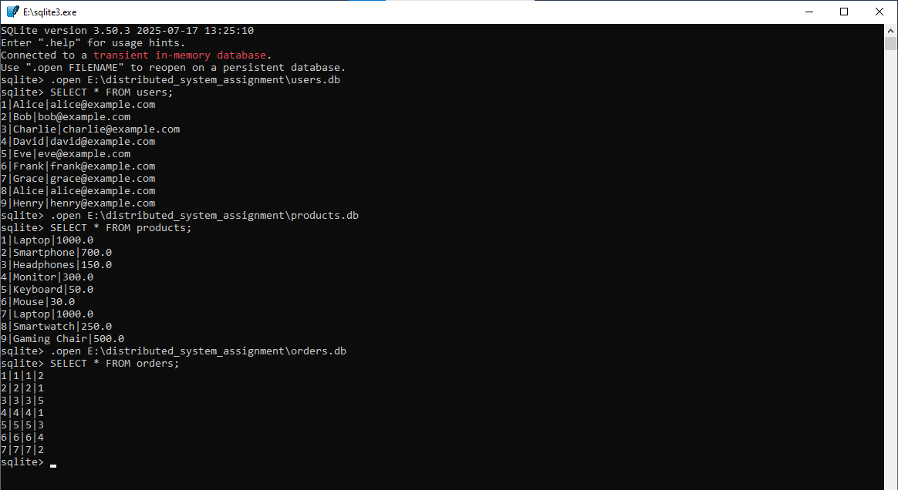

**7. Screenshots**

• **Users Table** – SQLite query result

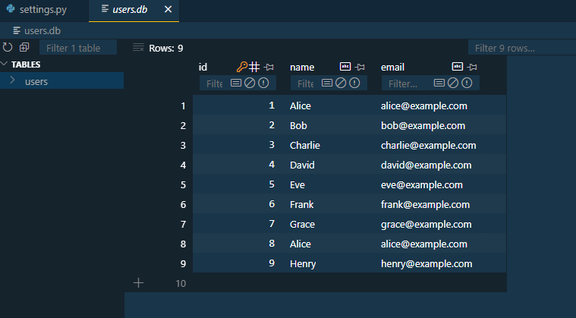

• **Products Table** – SQLite query result

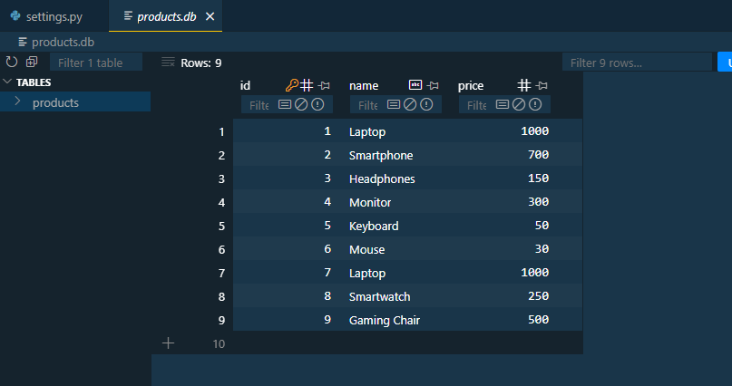

• **Orders Table** – SQLite query result

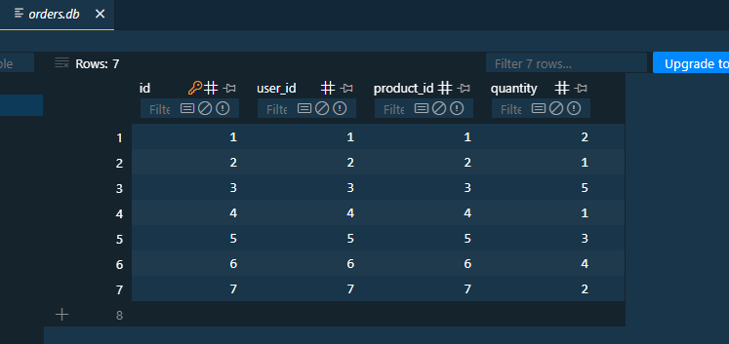

## ****8. Conclusion****

* Implemented a Django project with **three separate SQLite databases**.
* Performed data insertion concurrently using **threads**.
* Applied **validations in Python**, ensuring only valid data is stored.
* Verified the final records using **SQLite queries**.
* Final Result: **9 users, 9 products, 7 orders (invalid records skipped as per rules)**.